0-1 bfs
at a time humesa queue me 2 hi level hote hai.
Lets we have two types of waits, then also we can find shortest path using bfs (all wts. Given are either 0 or 1)

we use dequeue in this...
as agar weight zero hai then we push it same level in front,
agar weight 1 thi, then we push it in next level.

Examlple question.
Link https://www.codechef.com/problems/REVERSE
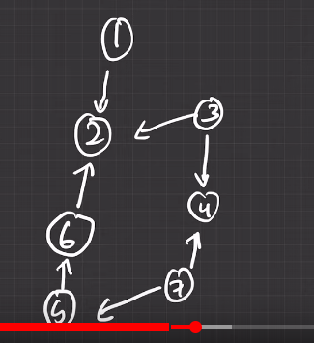
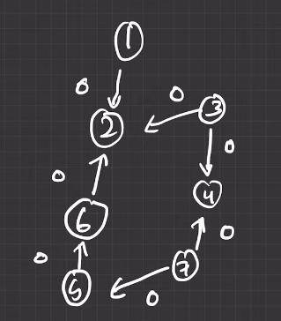

LET’ zero likhte hai sare weight ko

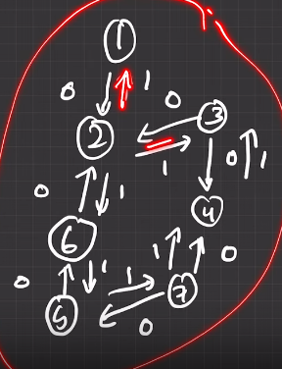
now draw a reverse edge of 1 in each

now, ans is

#include<bits/stdc++.h>
using namespace std;
const int N=1e5+10;
const int INF = 1e9+10;

vector< pair< int , int> >g[N]; //pair used, as graph is weighted
vector<int> level(N, INF); // level array
int n, m; // we doesn't need visited array in 0-1 dfs

int bfs(){
deque<int> q;
q.push_back(1);
level[1]=0;

while(!q.empty()){
int cur_v = q.front();
q.pop_front();

for( auto &child : g[cur_v]){
int child_v = child.first;
int wt = child.second;
if( level[cur_v] + wt < level[child_v]){
level[child_v] = level[cur_v]+wt;
if(wt==1){
q.push_back( child_v); // in necxt level
}
else{
q.push_front(child_v); // else in same level

}
}
}
}
return level[n]==INF ? -1 : level[n];
}

int main(){
cin>>n>>m;
for( int i=0 ;i<m ; i++){
int x,y;
cin >> x >> y;
if(x==y) continue; // for selfloop
g[x].push_back({y,0}); // by default 0 dal rhe hai
g[y].push_back({x,1}); // reverse dalte hai hai
}

cout<<bfs()<<endl;
}

i/p
7 7
1 2
3 2
3 4
7 4
6 2
5 6
7 5

o/p
2

